App Name: Poll Buddy (No longer PollBuddy)

|  |  |  |
| --- | --- | --- |
| **Name** | **Hex** | **Color** |
| Darkest Purple Header Background | #25162c |  |
| Dark Purple  Main Background | #4d3658 |  |
| Base Purple  Logo BG | #7f6491 |  |
| Light Purple  Logo Text | #dfcfea |  |
| Dark Grey /  Near Black | #25292A |  |
| White  Most Text | #FFFFFF |  |
| Light Gray | #EEEEEE |  |
| Gray  Placeholder text | #707070 |  |

Logo Font: [Fredoka One](https://fonts.google.com/specimen/Fredoka+One)

Font: moolboran (not this font, I can’t import it into google docs)

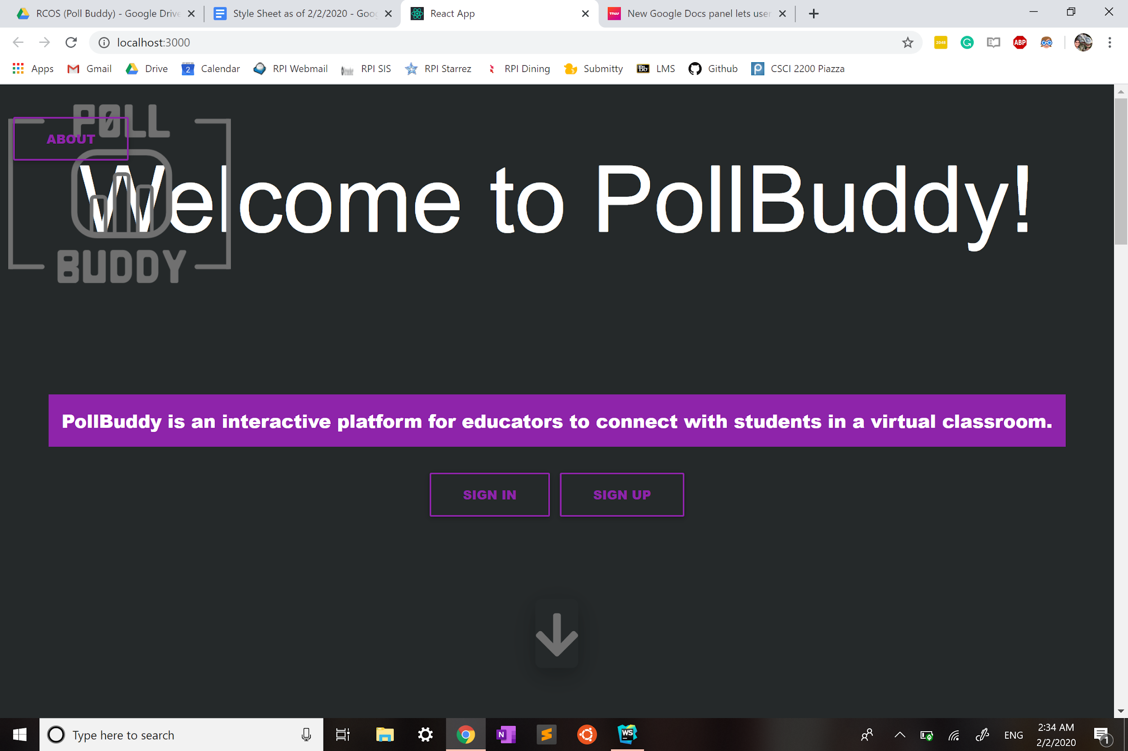

Terminology: (Real name first, unofficial and unused name after)

* Groups (AKA Classes, can contain Polls)
* Polls (AKA Lessons, comprises of multiple Questions)
* Questions (Part of Polls)

Design Guide:

* Text boxes
  + Label above, placeholder text inside
  + Colors: __________